Name : Pooja Harijiwan

Batch : SE-2021 Section : B

Department : Computer Science And Software Engineering

Example :

To check version

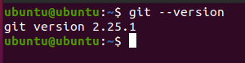

To configure for future use

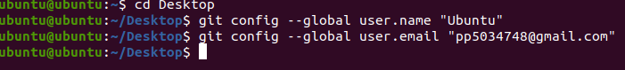

For Reading contents written in Git file:

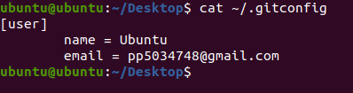

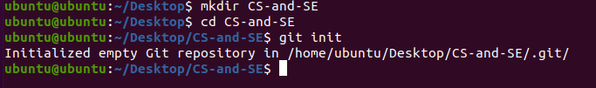

Step 4: Now we will set up the remote, which tells git where the repository is located.

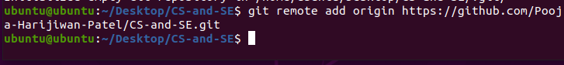

This command will add the user “test1” to the newly created group.

Group created:



To check group:

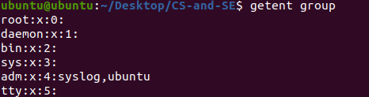

Now adding user:

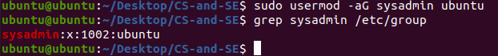

To check absolute path of current directory:



The following command changes the owner of newly created directory to sysadmins.





The following command changes the file permissions for the **CS-and-SE** directory. The flag **770** indecates that owner and the group will have all rights while the other users (o) will not have any rights on the directory and its files. To see the difference, compare the above screenshot with the current screenshot.

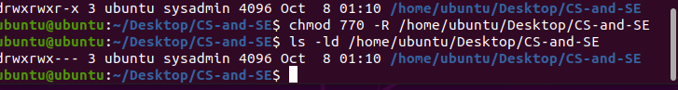

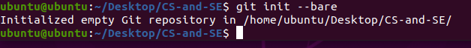

Bare or empty file initialization



At this point, you have successfully initialized a bare Git directory which is the central storage facility for the project. Try to do a listing of the directory to see all the files and directories in there:

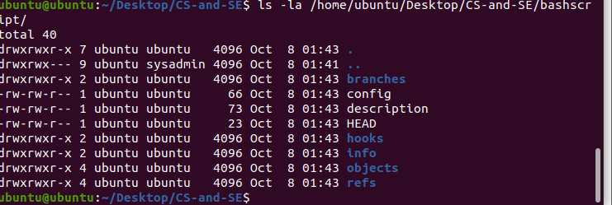

Cloning :

